**ETQ Assignment Documentation**

1. **Object Oriented Design for Database**

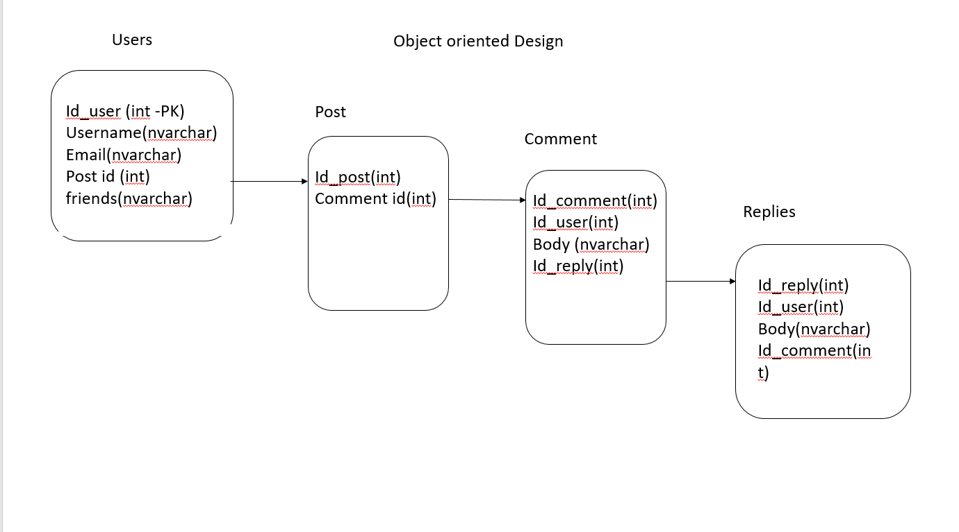

1. **Design Database “social_database” in Mysql Workbench**

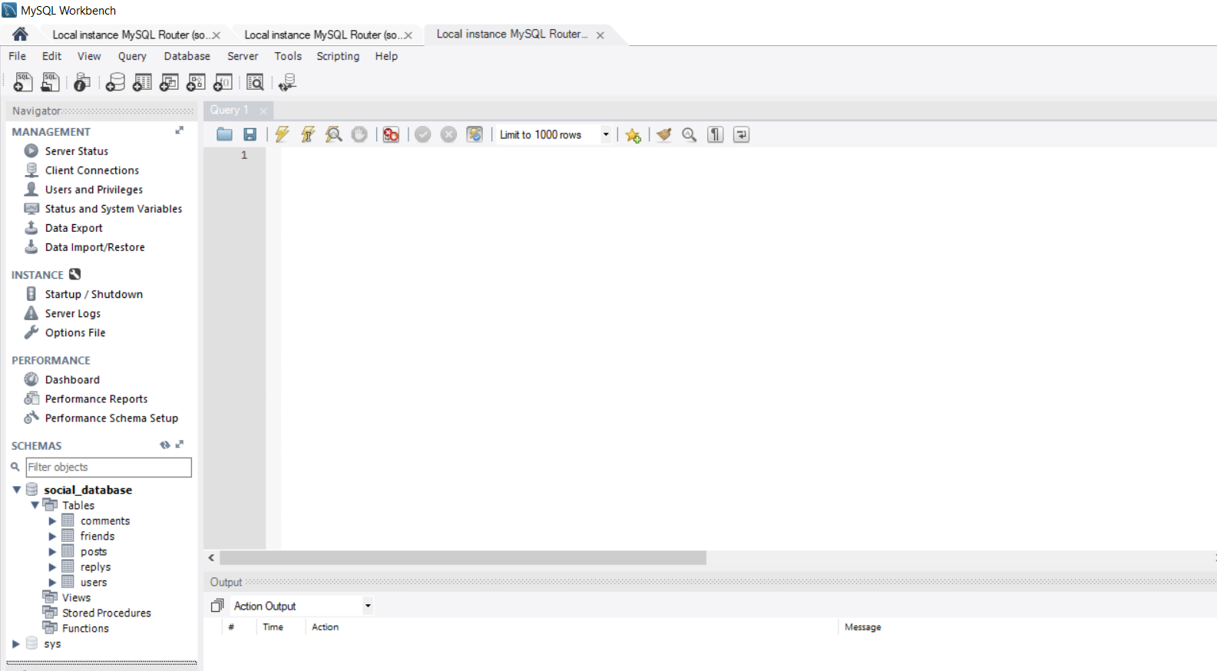

1. **Design all class using Netbeans**

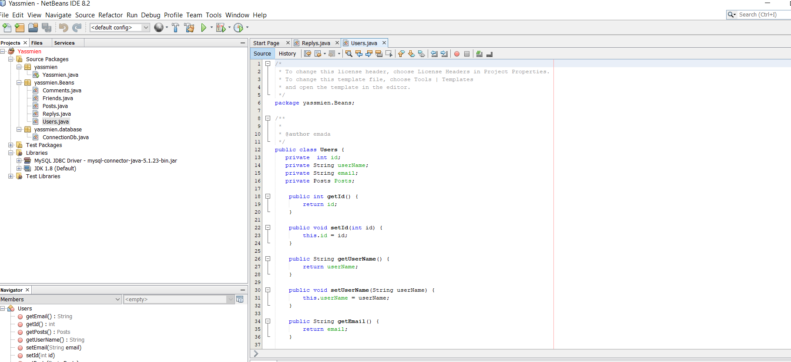

1. In Netbeans project, add Libraries for MySQL JDBC Driver

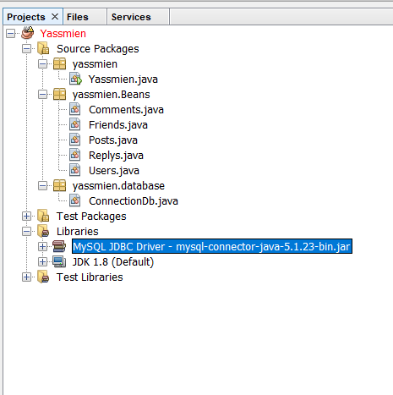

1. In Services tab, I make these steps
2. Right click on Database, Register MySQL server

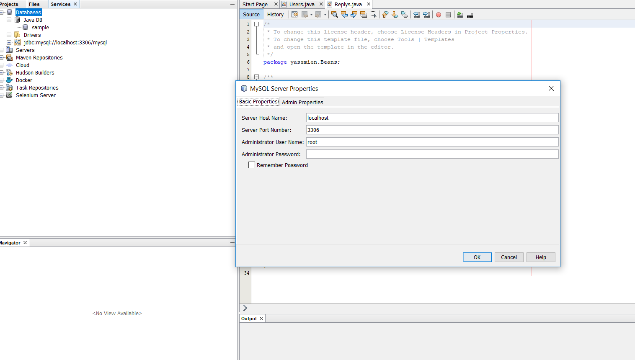

1. Connect MySQL Server at localhost:3306

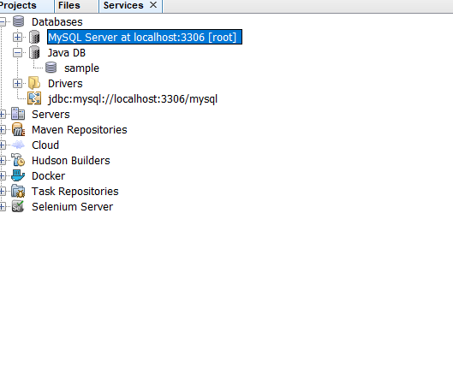

1. Connect jdbc:mysql:// localhost:3306/mysql

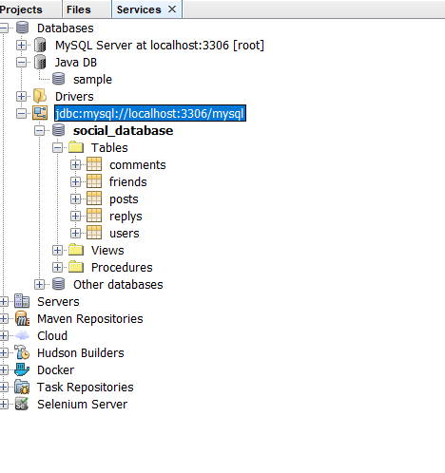

1. Select **social_database** as default, them display the tables

**5) Check connection**

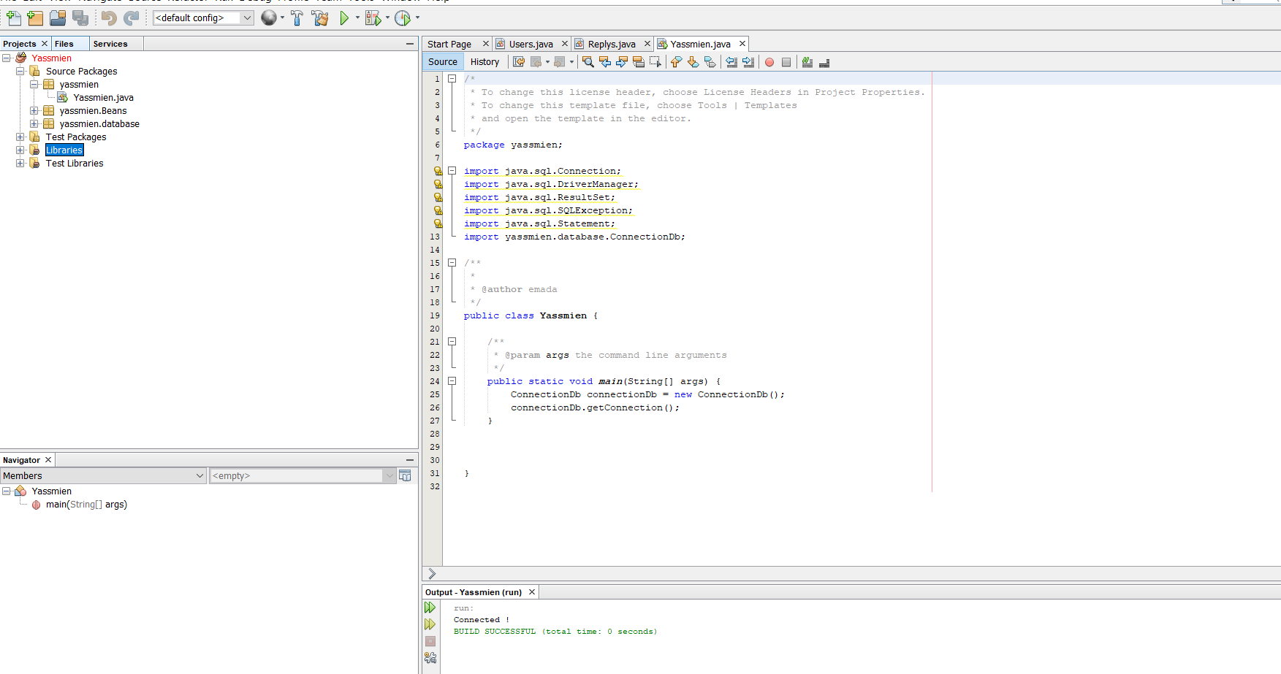

6) UI Design: right click on project, then add JFrame Form which is **app**

**7) set jframe for user as main class, using**

**Poject -- > right click -- > property -- > run -- > main class -- > create user jframe**

**8) UI Steps**

**Firstly, I create UI for create new user**

**Then, go to login screen**

**Then Post – Here I have problem, I can’t take id of user, I need more time to make it**

**I create 4 UI (Create User, Login, Communication, post)**

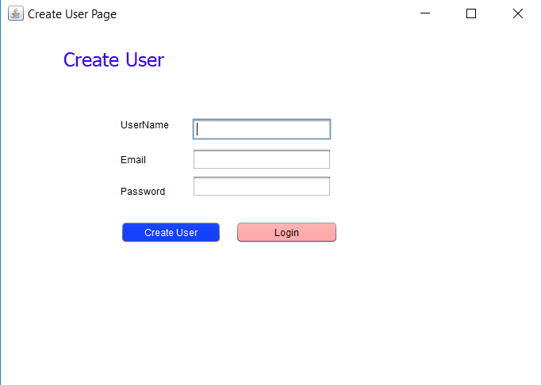

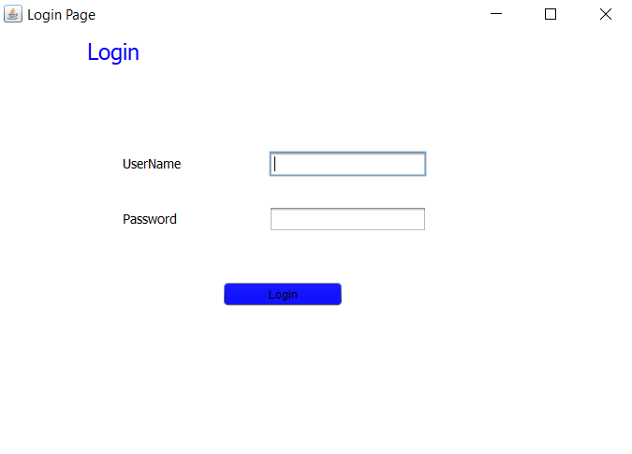

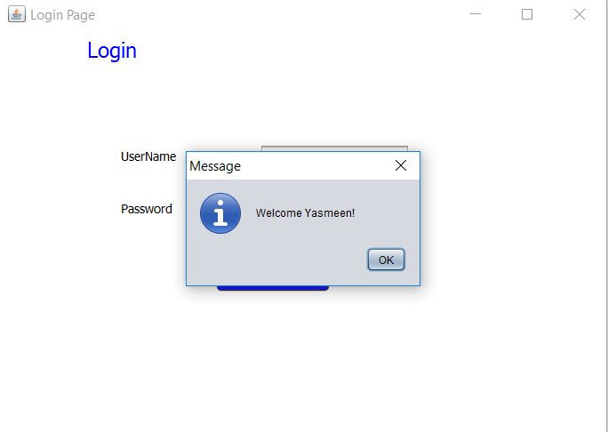

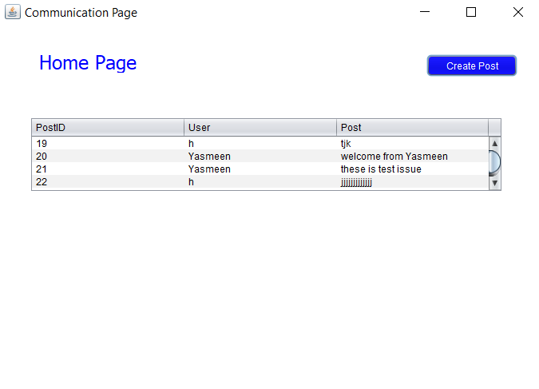

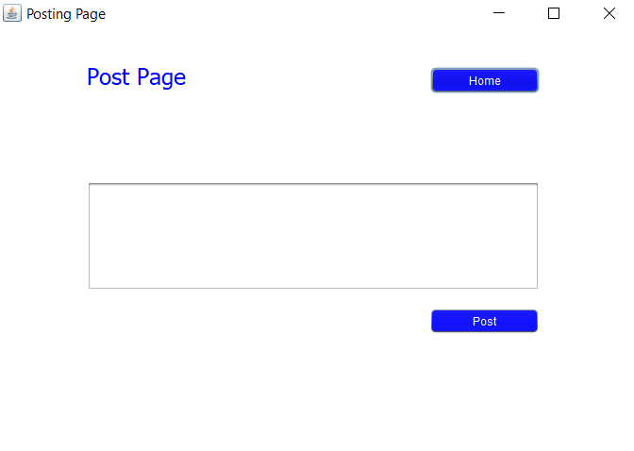

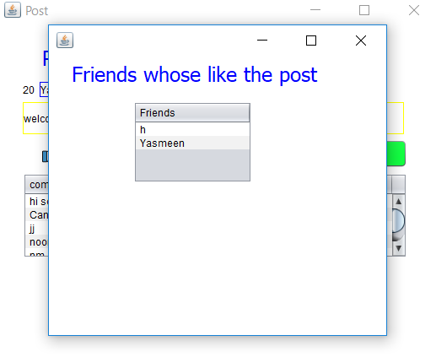

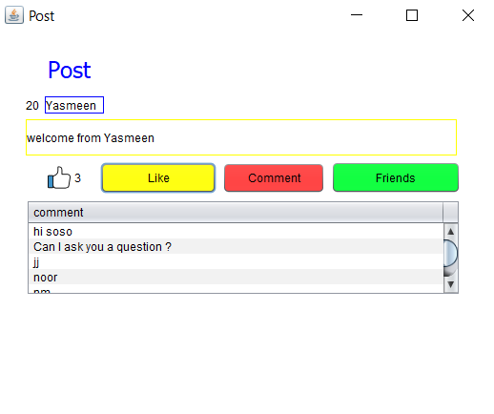

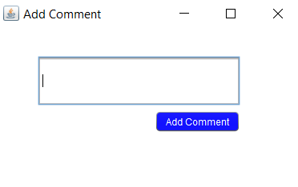

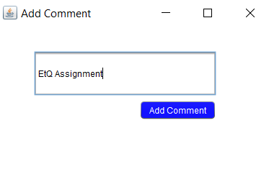

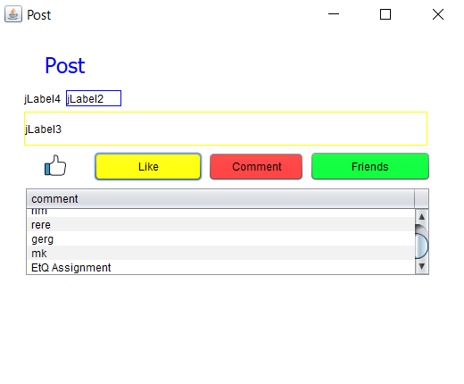

**9)download rs2xml.jar to use import net.proteanit.sql.DbUtils; to retrieve data from database in table**

**10) Make project as exe file using**

**Run -- > clean and build**